Chandra Mohan Lakhinana

Humidity and PIR sensor for Door Indoor weather monitoring

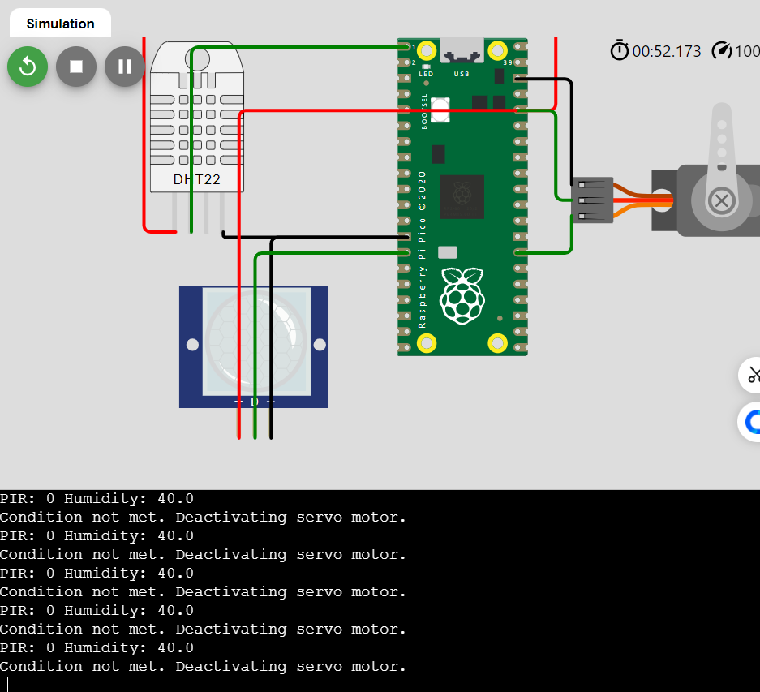

Working Code:

from machine import Pin, PWM

from time import sleep

import dht

# Define threshold for humidity

HUMIDITY_THRESHOLD = 70  # Adjust the threshold as needed

# Setup PIR sensor

pir_sensor = Pin(10, Pin.IN)

# Setup DHT22 sensor

dht_sensor = dht.DHT22(Pin(0))

# Setup servo motor

servo = PWM(Pin(21))

servo.freq(50)  # 50Hz for servo motor

# Function to set servo angle

def set_servo_angle(angle):

    # Duty cycle for the given angle (0-180 degrees mapped to duty_u16 range 0-65535)

    min_duty = 1638  # 2.5% duty cycle

    max_duty = 8192  # 12.5% duty cycle

    duty = int((angle / 180) * (max_duty - min_duty) + min_duty)

    servo.duty_u16(duty)

try:

    while True:

        # Read PIR sensor

        pir_value = pir_sensor.value()

        # Read DHT22 sensor

        dht_sensor.measure()

        humidity = dht_sensor.humidity()

        # Print sensor values for debugging

        print("PIR:", pir_value, "Humidity:", humidity)

        # Check if the conditions are met to start the motor

        if pir_value == 1 or humidity > HUMIDITY_THRESHOLD:

            print("Condition met. Activating servo motor.")

            set_servo_angle(0)  # Set servo to 0 degrees (activate)

        else:

            print("Condition not met. Deactivating servo motor.")

            set_servo_angle(-90)  # Set servo to -90 degrees (deactivate)

        # Wait for a second before next reading

        sleep(1)

except KeyboardInterrupt:

    print("Program stopped")